**Government Polytechnic,Pune-16**

**(An Autonomous Institute of Government of Maharashtra)**



**A Microproject On :**

“Creating a personal blog and host it on github”

Submitted by:

|  |  |
| --- | --- |
| Shriya Rajeev Kulkarni | 2406114 |
| Samruddhi Harish Lambhate | 2406118 |
| Aditi Harnesh Palpinkar | 2406139 |
| Gouri Umesh Panchal | 2406140 |

Under the Guidence of:

Smt. R.chavhan

**DEPARTMENT OF COMPUTER ENGINEERING**

(Academic Year: 2024-25)

**GOVERNMENT POLYTECHNIC PUNE**

(An Autonomous institute of Government of Maharashtra)

**DEPARTMENT OF COMPUTER ENGINEERING**

Academic Year 2024-25



**CERTIFICATE**

This is to certify that micro-project work entitled **“**Creating a personal blog and host it on github

Bonafide work carried out by:

Of class First Year in partial fulfillment of the requirement for the completion of Course of Diploma **Introduction to Open source Technologies** (CM21206) in Computer Engineering from Government Polytechnic, Pune. The report has been approved as it satisfies the academic requirements in respect to microproject work prescribed for the cause

|  |  |
| --- | --- |
| Shriya Rajeev Kulkarni | 2406114 |
| Samruddhi Harish Lambhate | 2406118 |
| Aditi Harnesh Palpinkar | 2406139 |
| Gouri Umesh Panchal | 2406140 |

…………………………. ……………………….. ………………………….

**Microproject Guide H.O.D Principal**

(Smt. R.Chavhan) (Smt. J.R. Hange) (Dr.R.K.Patil)

ACKNOWLEDEGEMENT  
Creating this personal blog has been an exciting journey, and I would like to take a moment to express my sincere gratitude to those who made it possible.

First and foremost, I extend my appreciation to **GitHub** for providing an incredible platform that allows developers and creators like me to host and share content seamlessly. The power of GitHub Pages has made it easy to bring this blog to life.

A special thanks to the developers and contributors behind **[Jekyll/Hugo/Hexo/Next.js]** (or any framework you used) for building such a powerful and user-friendly static site generator. The open-source ecosystem continues to inspire and empower individuals to create without limitations.

I am also deeply grateful to the countless bloggers, tutorial creators, and online communities who have shared their knowledge and expertise. Whether through blog posts, YouTube tutorials, Stack Overflow discussions, or documentation, their insights have helped me navigate the process of setting up, customizing, and deploying my blog.

Finally, a heartfelt thank you to my friends, family, and readers who support and encourage my journey in content creation. Your feedback, suggestions, and engagement inspire me to keep sharing and improving.

This blog is more than just a personal project—it's a platform for learning, growth, and connection. I look forward to evolving it further and giving back to the community that has helped me so much.

Thank you all! 🚀✨

ABSTRACT

In the digital age, personal blogs serve as a powerful medium for sharing knowledge, experiences, and ideas with a global audience. This project focuses on the creation and deployment of a personal blog using modern static site generation tools and hosting it on GitHub Pages. The process involves selecting an appropriate framework such as Jekyll, Hugo, or Hexo, customizing themes and layouts, and integrating features to enhance user experience. GitHub provides a reliable and cost-effective hosting solution, leveraging version control for efficient content management.

This abstract outlines the step-by-step process of setting up a blog, from repository initialization to domain configuration and continuous deployment. Additionally, it highlights best practices for optimizing performance, ensuring security, and improving discoverability through SEO strategies. By leveraging open-source technologies and GitHub's hosting capabilities, individuals can create and maintain a professional and scalable personal blog with minimal costs and technical overhead. This project serves as a guide for aspiring bloggers and developers looking to establish their online presence efficiently.

**Index**

|  |  |  |
| --- | --- | --- |
| **SR.NO.** | **Content** | **Page no** |
| **1** | **Introduction** | **1-7** |
| **2** | **Algorithm** | **8-12** |
| **3** | **Concepts used in Project** | **13-16** |
| **4** | **Coding** | **17-27** |
| **5** | **Output** | **28-29** |
| **6** | **Conclusion** | **30-31** |

**INTRODUCTION**

**Hosting a personal blog on GitHub is an excellent way to share your thoughts, ideas, and projects with the world, all while taking advantage of GitHub’s free hosting capabilities. By using GitHub Pages, you can create and deploy a static website directly from a GitHub repository, making it an ideal choice for personal blogs, portfolios, or project documentation.**

**GitHub Pages allows you to easily set up and maintain a blog using simple web technologies like HTML, CSS, and Markdown. Additionally, you can use static site generators like Jekyll (which is natively supported by GitHub Pages), allowing you to create dynamic blog posts without needing to deal with complex server-side scripting.**

**The process is straightforward, requiring only basic knowledge of GitHub, Markdown, and web design. Once set up, your blog is hosted for free and will be accessible under the URL https://username.github.io/. Whether you're an experienced web developer or a complete beginner, GitHub Pages provides an accessible, flexible, and free way to host your personal blog, giving you complete control over both the content and design.**

**In this guide, we’ll walk you through the process of creating, customizing, and hosting your own personal blog on GitHub, step by step.**

**INTRODUCTION TO GITHUB**

**GitHub is a web-based platform for version control and collaboration, primarily used by developers to store and manage code. It is built on Git, a distributed version control system that tracks changes in files and allows multiple people to work on a project simultaneously without interfering with each other’s work.**

**GitHub allows users to create repositories (or "repos"), which are essentially project directories where code, documentation, and other project-related files are stored. These repositories can be made public or private, depending on the user’s needs. With GitHub, developers can push and pull code, track issues, and collaborate through pull requests, making it an essential tool for open-source development and team projects.**

**One of the key features of GitHub is its ability to facilitate collaboration. Users can contribute to others' projects, suggest changes, and submit code reviews through pull requests. GitHub also offers tools for continuous integration, issue tracking, and project management, making it a comprehensive solution for developers and teams of all sizes.**

**GitHub is not just for developers—it is also widely used by content creators, designers, and anyone who needs to store, share, and collaborate on files. Additionally, GitHub Pages offers users a way to host static websites for free, which is a popular option for personal blogs, portfolios, and project documentation.**

**In summary, GitHub is a powerful platform for version control, collaboration, and hosting, making it a vital tool for developers and anyone involved in creating and managing digital projects.**

DETAILED ALGORITHMS

**Step 1: Set Up a GitHub Account**

1. **Create a GitHub Account**:
   * Go to [GitHub](https://github.com) and sign up for an account if you don’t have one already.
   * Complete the registration process by verifying your email address.

**Step 2: Create a New Repository for Your Blog**

1. **Go to the GitHub Homepage**:
   * Once logged in, navigate to the GitHub homepage.
2. **Create a New Repository**:
   * Click the “+” sign in the upper-right corner of the page and select **"New repository"**.
   * Name the repository **username.github.io**, where username is your GitHub username. This naming convention is essential for hosting personal websites.
   * Choose **Public** for the repository visibility (so others can see your blog).
   * Initialize the repository with a README.md file (this is optional but helps set up the repo).

**Step 3: Set Up GitHub Pages**

1. **Navigate to the Repository Settings**:
   * Go to the repository’s **Settings** tab.
2. **Enable GitHub Pages**:
   * Scroll down to the **GitHub Pages** section.
   * Under **Source**, select the **main branch** as the source (or master if that's your default branch).
   * Optionally, you can select a folder like /docs for a more organized structure, but for now, let’s go with the root directory.
3. **Save Changes**:
   * GitHub will generate a URL like https://username.github.io for your blog.
   * Note down this URL, as this will be the address of your hosted blog.

**Step 4: Choose a Static Site Generator (Optional but Recommended)**

1. **Decide on the Generator**:
   * You can manually create the HTML and CSS files for your blog, but using a Static Site Generator (SSG) like **Jekyll** makes the process easier.
   * **Jekyll** is integrated directly with GitHub Pages and is highly recommended for blogs.
2. **Set Up Jekyll (or Another Generator)**:
   * If you want to use Jekyll, you can either:
     + Clone a Jekyll theme or start with a basic Jekyll template.
     + Or, you can use other generators like **Hugo** or **Gatsby**, depending on your preference.
   * For Jekyll:
     + Create a new repository, or clone the official **Jekyll theme**.
     + Download the theme or template files and place them into the repository folder.

**Step 5: Customize Your Blog’s Design and Content**

1. **Customize the _config.yml (Jekyll Only)**:
   * In the root directory of your repository, locate the _config.yml file.
   * Modify fields like title, description, and url to match your blog’s purpose and style.
2. **Add Blog Posts**:
   * In Jekyll, blog posts are stored in the _posts directory.
   * Create a new .md (Markdown) file in the _posts directory, using the naming convention: YYYY-MM-DD-title.md (e.g., 2025-04-01-my-first-post.md).
   * In each .md file, add the following:
     + Front matter: metadata about the post (title, date, etc.)
     + Content: your blog post written in Markdown.

Example of a blog post in Markdown:

markdown

Copy

---

layout: post

title: "My First Blog Post"

date: 2025-04-01

---

Welcome to my first post on my personal blog!

1. **Customize the Theme**:
   * Modify the HTML and CSS files to adjust the appearance of the blog. You can:
     + Add custom styles in the assets folder.
     + Edit the index.html or default.html files to adjust the layout.
   * Alternatively, you can install a pre-designed theme, either from Jekyll’s theme gallery or another source like [Jekyll Themes](https://jekyllthemes.io/).

**Step 6: Add Content and Media**

1. **Create Additional Pages**:
   * To create static pages like an "About Me" or "Contact" page, create new .md files and place them in the root directory.

Example:

markdown

Copy

---

layout: page

title: "About Me"

---

Hello! I'm a passionate writer and developer, and this is my personal blog.

1. **Add Media (Images, Videos, etc.)**:
   * Upload any images or videos you wish to include in your posts.
   * You can store them in a folder like /assets/images/ for easy reference in your posts or pages.

**Step 7: Commit and Push Changes**

1. **Commit the Files**:
   * If you're using Git locally, make sure to commit all the changes (themes, posts, customizations, etc.) to the repository.

Example:

bash

Copy

git add .

git commit -m "Initial blog setup"

git push origin main

1. **Verify the Website**:
   * Once pushed, go to the GitHub Pages URL (e.g., https://username.github.io) to view your live blog.
   * Any updates made and pushed to GitHub will automatically update the blog.

**Step 8: Customize Domain Name (Optional)**

1. **Set Up a Custom Domain** (Optional):
   * If you want a custom domain (e.g., www.myblog.com), you can set up a domain and point it to GitHub Pages.
   * In the repository’s **Settings**, under **GitHub Pages**, you can enter your custom domain name.
   * You will also need to configure the DNS settings with your domain provider to point to GitHub’s servers (using CNAME records).

**Step 9: Maintain Your Blog**

1. **Add New Posts**:
   * Whenever you want to add a new blog post, create a new .md file in the _posts directory.
   * Commit and push the changes to your GitHub repository.
2. **Update Content**:
   * If you want to change any page or the design, update the HTML, CSS, or Markdown files and push the changes.
3. **Monitor for Issues**:
   * Use GitHub’s issue tracking system to monitor any problems or enhancements you might want to address.

CONCEPTS USED IN THE MICROPROJECT

hosting a personal blog on GitHub, several key concepts come into play. These concepts are primarily related to GitHub, GitHub Pages, and static website generation. Below are the main concepts used when setting up and hosting a personal blog on GitHub:

**1. GitHub Repositories**

* **Repository: A repository (or repo) is a project or directory that contains all of your blog files, including code, images, styles, and posts. It’s the foundation of your project on GitHub.**
* **Public/Private Repositories: GitHub repositories can either be public (visible to everyone) or private (only visible to specific users). For a personal blog, you generally want it to be public.**
* **GitHub URL: Every repository has a unique URL. For GitHub Pages, your blog repository will typically be https://username.github.io.**

**2. Git and Version Control**

* **Git: Git is a distributed version control system that tracks changes in files. It allows multiple developers or contributors to work on a project without conflicting changes.**
* **Commit: A commit is a snapshot of your changes. You make a commit every time you save and push changes to the repository. GitHub allows you to track the history of your blog, including who made which changes.**
* **Push: Pushing is the process of sending your changes to GitHub from your local machine.**
* **Pull: Pulling updates from GitHub to your local environment ensures you have the latest version of the code.**

**3. GitHub Pages**

* **GitHub Pages: GitHub Pages is a feature that allows you to host static websites directly from a GitHub repository. It’s perfect for hosting personal blogs, portfolios, or project documentation.**
* **GitHub Pages URL: After setting up GitHub Pages, your website will be available at https://username.github.io. This URL is automatically generated based on the name of your repository.**
* **Branch for GitHub Pages: The content of your blog is served from a branch, typically the main or master branch of the repository. You can also configure GitHub Pages to serve content from a specific folder like /docs.**

**4. Static Website**

* **Static Website: A static website consists of HTML, CSS, and JavaScript files. Unlike dynamic websites, static websites don’t require a backend server and can be served directly from GitHub’s servers.**
* **Content: Your blog posts, pages (like "About Me" or "Contact"), and other website content are written in static formats such as Markdown (.md) files, which GitHub Pages can process and render into HTML.**

**5. Markdown**

* **Markdown: Markdown is a lightweight markup language used to write content in a plain-text format. It's often used for writing blog posts because it’s simple and easy to convert into HTML. For example, you can write a blog post like this in Markdown:**

**markdown**

**Copy**

**# My First Blog Post**

**Welcome to my first post on my personal blog!**

* **GitHub Pages supports Markdown and automatically converts .md files into HTML.**

**6. Jekyll (Static Site Generator)**

* **Jekyll: Jekyll is a static site generator that is integrated directly with GitHub Pages. It simplifies the process of creating and managing a personal blog by converting Markdown files into HTML and organizing content.**
* **Layouts and Templates: Jekyll uses layouts and templates to provide a consistent design across your blog. These layouts define how different pages (e.g., blog posts, homepage, etc.) will look.**
* **Front Matter: In Jekyll, the metadata for each blog post (title, date, author) is specified in the front matter of each Markdown file. It’s enclosed in --- at the top of the file.**

**Example:**

**yaml**

**Copy**

**---**

**title: "My First Blog Post"**

**date: 2025-04-01**

**---**

**7. GitHub Actions (Optional)**

* **GitHub Actions: GitHub Actions is a CI/CD (Continuous Integration/Continuous Delivery) tool that allows you to automate tasks like building and deploying your blog. For instance, you can automate the process of building your site with Jekyll and pushing it to GitHub Pages whenever changes are made to the repository.**

**8. CNAME (Custom Domain Name)**

* **CNAME: If you want to use a custom domain for your blog (e.g., www.myblog.com instead of username.github.io), you can configure a CNAME file in the root of your repository. This file specifies the domain name to be used with GitHub Pages.**
* **DNS Configuration: You need to configure DNS settings at your domain registrar to point to GitHub’s servers so that traffic to your custom domain is directed to your GitHub Pages site.**

**9. HTML/CSS/JS (Web Development Basics)**

* **HTML (HyperText Markup Language): HTML is the standard language used to create web pages. It defines the structure of your blog's content (headings, paragraphs, images, etc.).**
* **CSS (Cascading Style Sheets): CSS is used to style and design the appearance of your blog (colors, fonts, layout, etc.).**
* **JavaScript: JavaScript is used to add interactivity to your blog. While static sites usually require minimal JavaScript, you can add features like image sliders or form validation.**

**10. GitHub Issues (Optional)**

* **Issues: GitHub Issues is a feature for tracking bugs, tasks, or features in a project. You can use it to track improvements, new blog post ideas, or any bugs you encounter while building your site.**

**11. Cashing and Performance (Optional)**

* **CDN (Content Delivery Network): GitHub Pages uses a CDN to serve your content across the globe, ensuring fast load times for visitors, regardless of their location.**
* **Caching: GitHub Pages automatically caches your website’s content to improve load times. You can also implement additional caching strategies to make your blog even faster.**

**12. GitHub Forking and Collaboration (Optional)**

* **Forking: If you find a blog theme you like, you can "fork" the repository (make a copy) to start customizing it for your own needs.**
* **Collaboration: GitHub allows multiple users to collaborate on projects, which means you can invite others to contribute to your blog, especially if it’s open-source or if you’re working with others**

CODING

HTML CODE FOR MAIN PAGE:

**<!DOCTYPE html>**

**<html lang="en">**

**<head>**

**<meta charset="UTF-8">**

**<meta name="viewport" content="width=device-width, initial-scale=1.0">**

**<meta http-equiv="X-UA-Compatible" content="ie=edge">**

**<title>My Personal Blog</title>**

**<link rel="stylesheet" href="blog.css">**

**</head>**

**<body>**

**<header>**

**<div class="container">**

**<h1>My Personal Blog</h1>**

**<nav>**

**<ul>**

**<li><a href="#">Home</a></li>**

**<li><a href="#">About Me</a></li>**

**<li><a href="#">Blog</a></li>**

**<li><a href="#">Contact</a></li>**

**</ul>**

**</nav>**

**</div>**

**</header>**

**<div class="main-content">**

**<div class="container">**

**<section class="blog-posts">**

**<article class="post">**

**<h2>Welcome to My First Blog Post</h2>**

**<p class="date">April 1, 2025</p>**

**<p>This is my first blog post. I am excited to start sharing my thoughts, ideas, and projects with the world. Stay tuned for more!</p>**

**<a href="file:///C:/Users/gauri/Desktop/GOURI/ost%20microproject/firstblog.html" class="read more">Read More...</a>**

**</article>**

**<article class="post">**

**<h2>My first day in college</h2>**

**<p class="date">March 28, 2025</p>**

**<p>I’ve always been fascinated by coding and hence I decided to go into an engineering college and got into Government Polytechnic Pune.Here is my experience of my first day in college.</p>**

**<a href="file:///C:/Users/gauri/Desktop/GOURI/ost%20microproject/firstday.html" class="read-more">Read More...</a>**

**</article>**

**<!-- More posts can be added here -->**

**</section>**

**<aside class="sidebar">**

**<h3>About Me</h3>**

**<p>I'm a software developer, tech enthusiast, and writer. I blog about coding, personal development, and life experiences.</p>**

**<h3>Recent Posts</h3>**

**<ul>**

**<li><a href="#">Welcome to My First Blog Post</a></li>**

**<li><a href="#">How I Got Into Coding</a></li>**

**<!-- More recent posts -->**

**</ul>**

**</aside>**

**</div>**

**</div>**

**<footer>**

**<div class="container">**

**<p>&copy; 2025 My Personal Blog. All rights reserved.</p>**

**</div>**

**</footer>**

**</body>**

**</html>**

**CODE FOR CSS STYLE SHEET USED:**

**/* General Reset */**

**\* {**

**margin: 0;**

**padding: 0;**

**box-sizing: border-box;}**

**/* Body Styles */**

**body {**

**font-family: Arial, sans-serif;**

**line-height: 1.6;**

**color: #333;**

**background-color: #f4f4f4;}**

**/* Header */**

**header {**

**background-color: #333;**

**color: #fff;**

**padding: 10px 0;}**

**header .container {**

**width: 90%;**

**max-width: 1200px;**

**margin: 0 auto;**

**display: flex;**

**justify-content: space-between;**

**align-items: center;}**

**header h1 {**

**font-size: 2em;}**

**header nav ul {**

**list-style: none;**

**display: flex;**

**gap: 20px;}**

**header nav ul li a {**

**color: #fff;**

**text-decoration: none;**

**font-weight: bold;}**

**/* Main Content */**

**.main-content {**

**background-color: #fff;**

**padding: 20px 0;}**

**.main-content .container {**

**width: 90%;**

**max-width: 1200px;**

**margin: 0 auto;**

**display: flex;**

**justify-content: space-between;}**

**.blog-posts {**

**width: 70%;}**

**.blog-posts .post {**

**margin-bottom: 30px;**

**padding: 20px;**

**background-color: #f9f9f9;**

**border-radius: 8px;}**

**.blog-posts .post h2 {**

**font-size: 1.8em;**

**margin-bottom: 10px;}**

**.blog-posts .post .date {**

**font-size: 0.9em;**

**color: #777;**

**margin-bottom: 15px;}**

**.blog-posts .post .read-more {**

**color: #007BFF;**

**text-decoration: none;**

**font-weight: bold;**

**}**

**/* Sidebar */**

**.sidebar {**

**width: 25%;**

**background-color: #f4f4f4;**

**padding: 20px;**

**border-radius: 8px;}**

**.sidebar h3 {**

**font-size: 1.4em;**

**margin-bottom: 10px;}**

**.sidebar p {**

**font-size: 1em;**

**color: #555;**

**margin-bottom: 20px;}**

**.sidebar ul {**

**list-style: none;}**

**.sidebar ul li {**

**margin-bottom: 10px;}**

**.sidebar ul li a {**

**text-decoration: none;**

**color: #007BFF;**

**font-weight: bold;}**

**.sidebar ul li a:hover {**

**text-decoration: underline;}**

**/* Footer */**

**footer {**

**background-color: #333;**

**color: #fff;**

**padding: 10px 0;**

**text-align: center;}**

**footer p {**

**font-size: 1em;}**

**CODE FOR MY FIRST BLOG WEBPAGE:**

**<!DOCTYPLE html>**

**<html>**

**<head>**

**<title>My first blog</title>**

**<body>**

**<p><h1>Introduction:<h1>**

**<h3>Hello, and welcome to my very first blog! I am incredibly excited (and a little nervous) to be starting this new journey of sharing my thoughts, experiences, and passions with all of you. It feels surreal to finally have a space to express myself, and I can’t wait to connect with like-minded individuals and make new friends along the way.**

**This blog is something I’ve been thinking about for a while now, and I’m so glad to finally make it a reality. Whether you're here because you're curious about who I am, you're looking for inspiration, or you're just interested in reading about the things I love, I want to thank you for joining me on this adventure.</h3>**

**<h1>Why I Started This Blog:</h1>**

**<h3>So, why did I decide to start a blog in the first place? Well, I’ve always been passionate about writing, sharing stories, and engaging in conversations about things that matter to me. Over the years, I’ve come to realize that I have a lot of thoughts and ideas swirling around in my head—thoughts about life, personal growth, my studies, and the things that excite me. Starting a blog felt like the perfect way to get all of these ideas out of my head and into the world.**

**But more than that, I wanted to create a space where I could connect with others who share similar interests. This blog is meant to be a platform where I can share my experiences, but also learn from you, my readers. I believe in the power of community, and I hope that this blog becomes a place where we can inspire and encourage each other.</h3>**

**<h1>What You Can Expect from This Blog:</h1>**

**<h3>Now that you know a little about why I started this blog, you might be wondering what you can expect to find here. Well, here’s a sneak peek into the kinds of topics I’ll be covering:</h3>**

**<h1>Personal Stories and Reflections:</h1>**

**<h3>I’ll be sharing stories from my life, my experiences, challenges, and lessons learned along the way. You can expect to read about my personal growth journey and how I navigate the ups and downs of life.</h3>**

**<h1>Tech and Coding:</h1>**

**<h3>As a passionate tech enthusiast and someone who loves coding, I’ll be sharing tutorials, tips, and insights about software development, technology, and anything related to the digital world. If you’re someone who is interested in learning or keeping up with the latest trends in tech, this section is for you!</h3>**

**<h1College Life and Study Tips:</h1>**

**<h3> Since I’m currently pursuing my diploma, you’ll find posts about my college experiences, including my first day (like this one!), tips on studying, how to manage college life, and what I’ve been learning.</h3>**

**<h1>Inspiration and Motivation:</h1>**

**<h3>I believe that we can all use a little bit of inspiration, especially during tough times. I’ll share motivational posts, quotes, and reflections that have helped me push through challenges and stay positive.</h3>**

**<h1>Miscellaneous Topics:</h1>**

**<h3> Occasionally, I’ll throw in some random thoughts, book recommendations, or musings on anything that sparks my interest. I want this blog to be a place where I can express myself freely!</h3>**

**<h2>A Personal Note: Starting this blog feels like a new chapter in my life, and I’m genuinely excited about what the future holds. I hope to create meaningful content that resonates with you and that we can all grow together. Blogging is not just about writing posts; it’s about creating a community, and I’d love for you to be part of it.**

**Thank you so much for visiting my very first blog post! I can’t wait to continue sharing my journey with you. Don’t forget to subscribe or follow along so you don’t miss out on future posts. If you have any questions or comments, please feel free to leave them below—I’d love to hear from you</h2>**

**</body>**

**</html>**

**CODE FOR MY FIRST DAY IN COLLEGE WEBPAGE:**

**<!DOCTYPE html>**

**<html>**

**<head>**

**<title>My first day in college</title>**

**</head>**

**<body>**

**<p>**

**<h1>Introduction:</h1>**

**<h3>The first day of college is something that every student looks forward to with a mixture of excitement, nervousness, and curiosity. Today was my first day at diploma college, and I have to admit, it was a day filled with new experiences, faces, and emotions. From the moment I stepped onto the campus, everything felt surreal. It’s the beginning of a new chapter in my life, and I can already feel how this journey will shape me in the years to come.</h3>**

**<h1>The Morning Rush:</h1>**

**<h3>I woke up early this morning, nervous and excited at the same time. I wasn’t sure what to expect, but I knew I had to make a good impression. I quickly dressed in my neatest clothes, grabbed my bag with all the necessary supplies—pens, notebooks, and my ID card—and rushed out the door. On the way to college, I couldn’t help but feel a little anxious. This was a big change, after all.**

**As I arrived at the college, I was surprised by how large the campus was. The buildings were modern, and there were a lot of students walking around. It felt like I was stepping into a whole new world.</h3>**

**<h1>First Impressions:</h1>**

**<h3>The first thing I noticed was the diversity on campus. There were students from different backgrounds, each with their own stories and experiences. I had been used to a more familiar environment in school, but college felt like a much larger and more open space where everyone was coming together to pursue their own dreams.**

**I was assigned to a batch of students in the same diploma course, and I quickly found a few friendly faces who helped me feel more comfortable. We introduced ourselves and shared a bit about our backgrounds, and it was reassuring to know that others were feeling just as nervous as I was.</h3>**

**<h1>The Classes Begin:</h1>**

**<h3>After the initial introductions, we proceeded to our first lecture. The classroom was well-equipped with modern technology, and the atmosphere was different from what I was used to in high school. Our professor gave an engaging introduction to the course, which made me realize just how much I’m going to learn in the coming months.**

**The first day was mostly about getting to know the syllabus and the expectations for the course. It’s going to be a challenging journey, but I’m excited. I could tell that the teachers were passionate about their subjects, and that passion made me even more excited to dive into the course material.</h3>**

**<h1>Meeting New Friends:</h1>**

**<h3> One of the best parts of today was meeting new people. It’s funny how quickly you can bond with someone over the shared experience of being in a new place. I met a few classmates who seem like they will become great friends. We exchanged contact information and promised to study together in the future. I think it’s going to be great to have a study group to help each other out as the course progresses.</h3>**

**<h1>The Campus Life:</h1>**

**<h3>After classes, I explored the campus a little more. There were various student clubs and organizations holding booths, trying to recruit new members. I’m considering joining the tech club, as I’m really interested in coding and software development. The campus also had a café where I grabbed a cup of coffee and chatted with a few other students about their experiences. It’s amazing how much I learned in just one day.</h3>**

**<h1>The Conclusion:</h1>**

**<h3>As I sit here reflecting on my first day, I realize that this is just the beginning of an exciting new chapter. I know it won’t always be easy, but I’m ready to face the challenges that lie ahead. Today, I learned that college is not just about textbooks and lectures—it’s about personal growth, building relationships, and discovering what you’re truly passionate about.s**

**<h2>I’m looking forward to the days ahead, the knowledge I’ll gain, and the friendships I’ll make. The first day of college was everything I expected and more. Here’s to the start of something incredible!**

**Thank you for reading! Stay tuned for more updates on my college journey</h2></p>**

**</body>**

**</html>**

**OUTPUTS:**

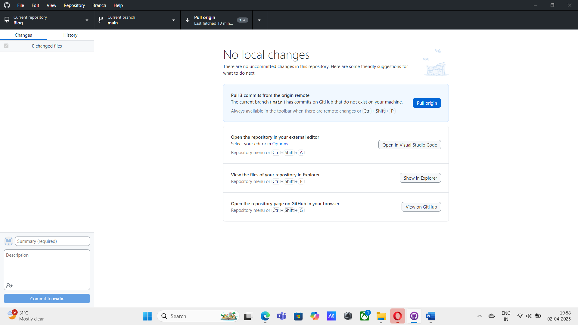

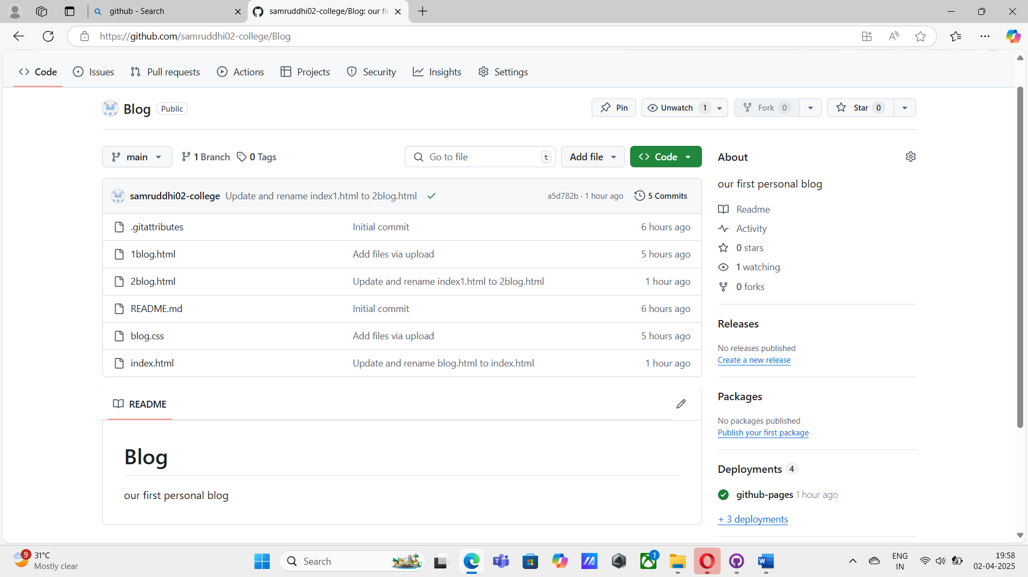

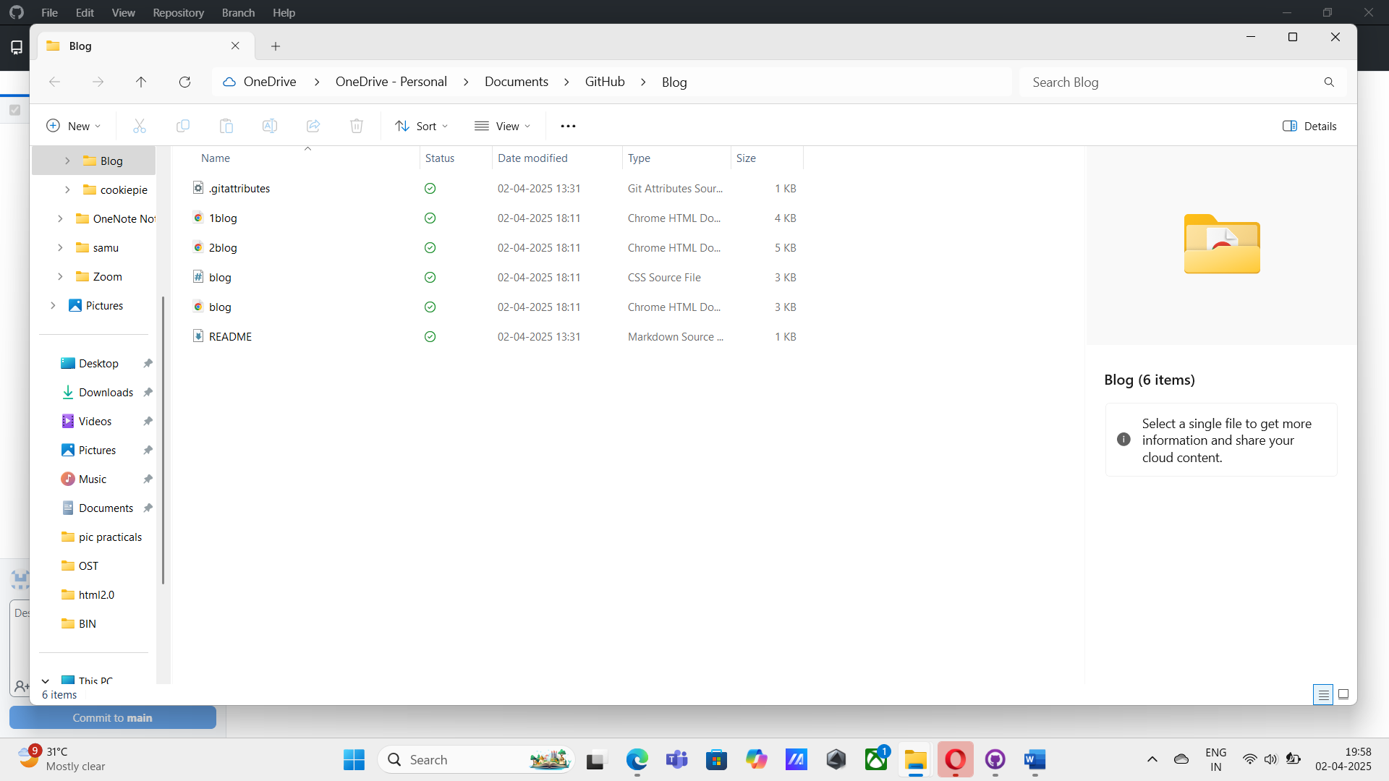

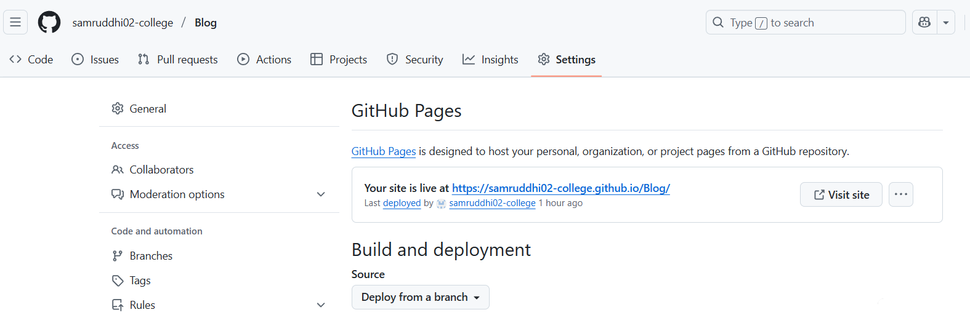

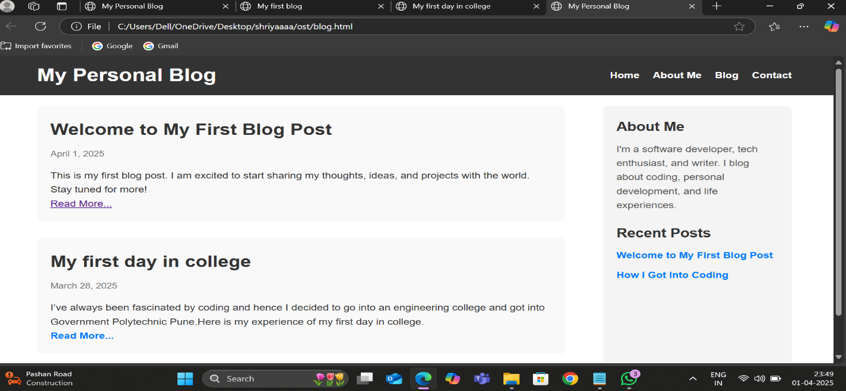

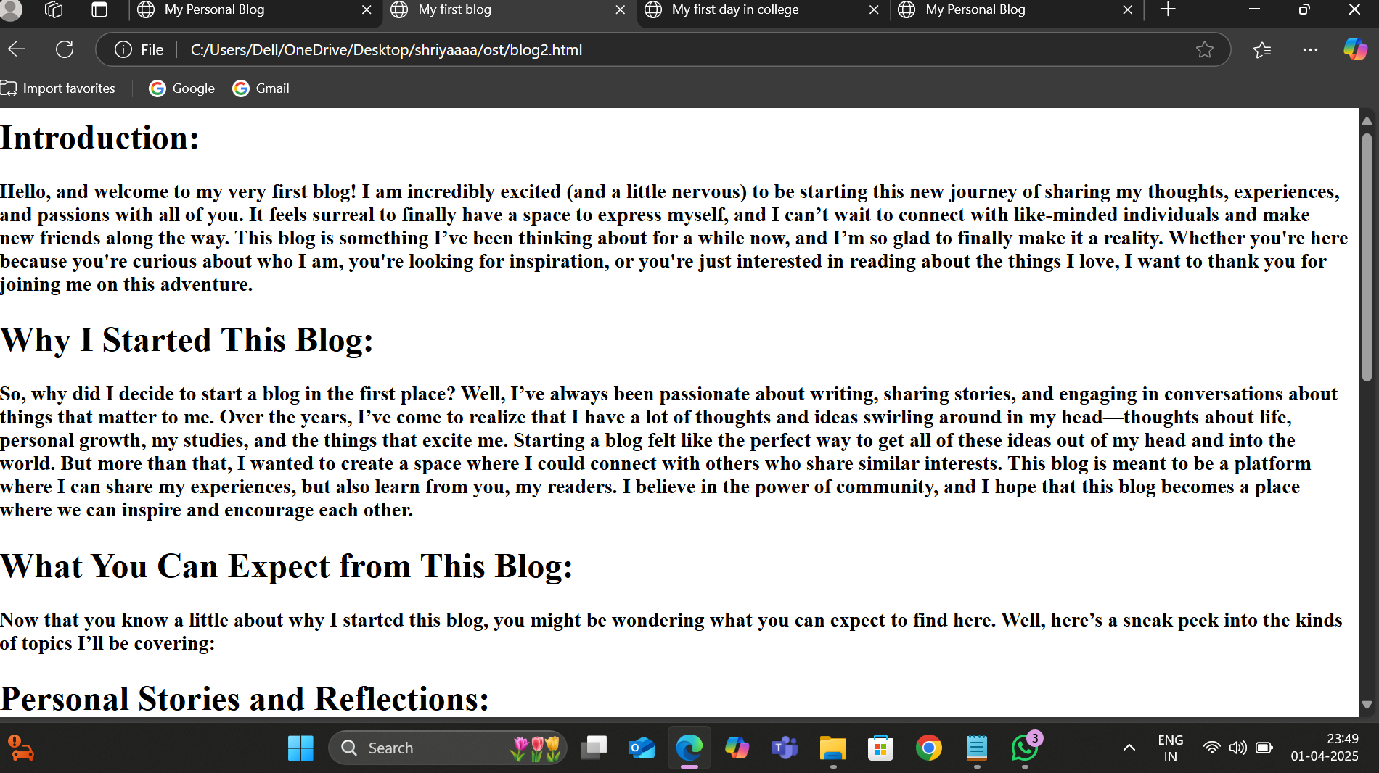

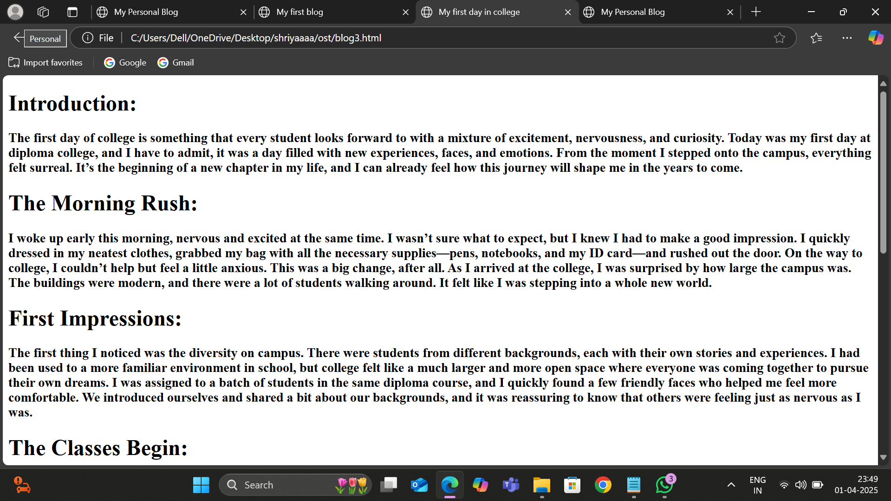

**CONCLUSION**

**Hosting a personal blog on GitHub is a powerful and cost-effective way to showcase your content to the world. By leveraging GitHub Pages, you can create a static, fast-loading website that doesn’t require any backend infrastructure, making it perfect for bloggers who want a simple yet professional platform. With the combination of version control provided by Git and the flexibility of Markdown, you can easily manage, update, and track your content.**

**Moreover, using GitHub Pages with a static site generator like Jekyll allows for seamless customization, enabling you to create a visually appealing and functional blog without the need for complex coding skills. The integration of a custom domain, the use of markdown for writing posts, and the ability to easily collaborate or contribute to open-source projects further enhance the experience.**

**Ultimately, hosting your personal blog on GitHub empowers you to take full control over your website, from design to content management. It's an excellent choice for developers, tech enthusiasts, and anyone looking to build a blog that is lightweight, easily maintainable, and free of charge. Whether you’re sharing personal stories, tutorials, or project updates, GitHub provides a simple yet effective platform to do so.**